Guide to Identification of Fresh Water Microorganisms

Microscopic autotrophic organisms (i.e. algae)

Name | Picture | Characteristic | Taxonomy
Green algae (with flagella, small)  <.05 mm | 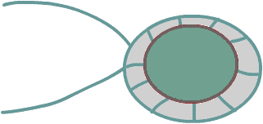 | - flagella  - small  - solitary  - rapid movement | Phylum Chlorophyceae  i.e. Chlamyolomonas sp.
Green algae  (with flagella)  .5-2mm |  | - spherical  - colonial  - with two flagella | Phylum Chlorophyceae  i.e. Volvox sp.
Green algae  (no flagella)  <.5 mm |  | - spherical to conical  - not attached to surface  - no movement | Phylum Chlorophyceae  i.e. Pediastrum sp.
Filamentous green algae  <.1 mm – cms | 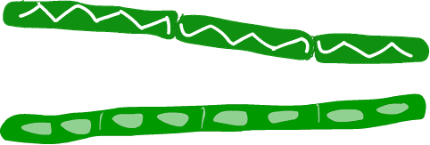 | - non branching  - chains of cells with chloroplast  - no flagella | Phylum Gamophyceae  i.e. Zygnema sp.  Spirogyra sp.
Desmids  <.5 mm | 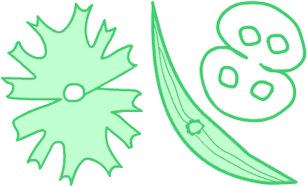 | - green  - no flagella  - mainly solitary, some colonial  - various shapes  - two semi-cell, mirror image | Phylum Gamophyceae  I.e. Desmidium sp  Closterium sp.
Diatoms  <.5 mm | 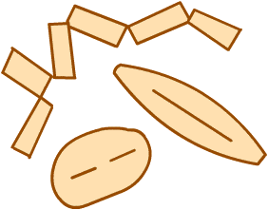 | - one cell  - slow gliding motion  - solitary or colonial  - cell wall (frustules) made of silica | Phylum Bacillariophyceae  i.e. Pennales, Centric

Protozoa – heterotrophic only

Name | Picture | Characteristic | Taxonomy
Flagellates  <.5mm | 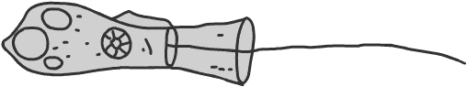 | - one or more flagella  - colonial or free living  - with or without lorica | Zoomastigophora  i.e choanoflagellates
Amoeba  .02 –5 mm | 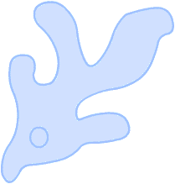 | - pseudopodia  - slow movement  - engulfs food | Sacrodina  Order Amoebina  i.e. Amoeba proteus
Shelled Amoeba  .1-.4 mm | 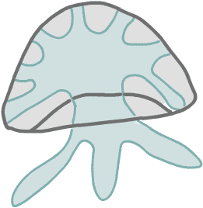 | - amoeba with a shell, usually sand grains  - pseudopodia  - slow movement | Sacrodina  Order Testacea  i.e Arcella sp.
Heliozoans  .01-1 mm | 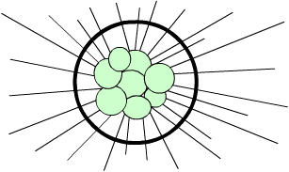 | 1. spherical  2. radiating hair like pseudopods  3. no movement | Sacrodina  Order Heliozoea
Ciliates – Peritrich  < .25 mm | 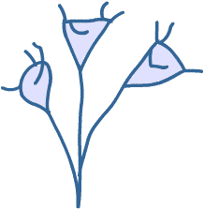 | - cylindrical or bell shaped bodies  - undulating cilia  - some stalked  - often colonial  - attached to different substrate | Ciliophora  Order Peritrichida  i.e. Vorticella sp.
Ciliates – Suctoria  <.7 mm | 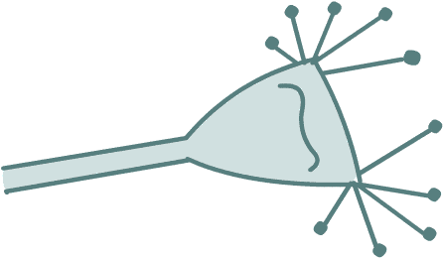 | - no cilia, sticky tentacles  - some attached to other organisms (i.e. Suctoria) | Ciliophora  Order Eridogenida  i.e. Tokophyra sp.
Ciliates  Paramecium  .01 – 4mm | 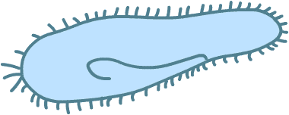 | - mostly free living forms  - cell of fixed shape  - movement by contraction and use of cilia  - fixed mouth and anal pore | Ciliophora  Order Oliogohymenophorea  i.e. Paramecium sp
Ciliates  Stentor  .01 – 4 mm | 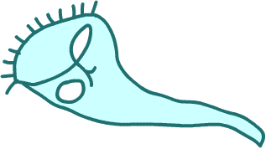 | - large body  - contractile  - cilia on mouth end | Ciliophora  Orer Heterotrichea  i.e. Stentor sp.
Ciliates  Coleps  .01-4mm | 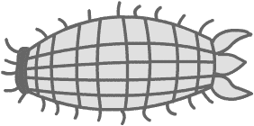 | - barrel-shaped  - spinous projection at posterior end  - cytosome apical | Ciliophora  Order Prostomatea  i.e. Coleps sp.

Other fresh water plankton (Animalia, Monera, etc)

Name | Picture | Characteristic | Taxonomy
Blue-green algae  (cyanobacteria) |  | - blue green color  - gliding movement  - prokaryote | Kingdom Monera  i.e. Annabella sp.
Euglenoids  <.4mm | 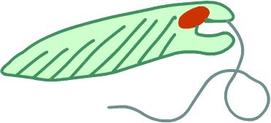 | - sometimes green  - flagellate  - red eye spot | Phylum Euglenida  i.e. Euglena sp.
Dinoflagellates  <.4mm | 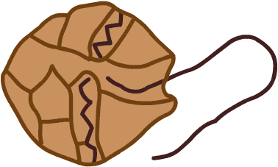 | - free swimming  - tough armor  - flagellate  - autotrophic, heterotrophic | Phylum Dinoflagellate
Rotifers  .4mm - 2 cm | 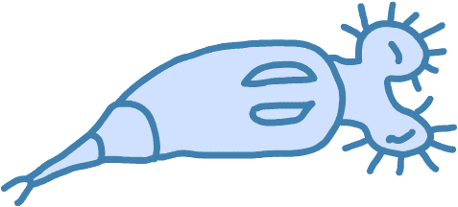 | - corona with cilia  - hairy appendages  - transparent with lorica  - free swimming or attached  - organs, compressed body | Phylum Rotifer  Class Bdelloided  Class Monogononta
Hydra  2 cm | 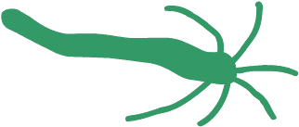 | - green brown or colorless  - body and tentacles contract and stretch  - primitive organs | Phylum Cnidaria  i.e. Hydra sp.
Flatworms  1-15+ mm | 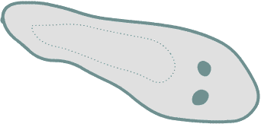 | - flattened  - eye spots  - move in gliding motion | Phylum Platyhelminthes  Class Turbellaria  I.e. Planaria sp.
Roundworms  .2-10 mm |  | - moves in rapid “s” form  - round body  - bilateral  - anterior, posterior openings | Phylum Nematodes
Oligochaetes  1.5 mm - >2 cm | 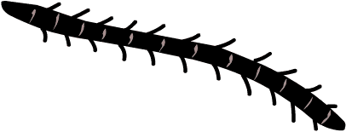 | - segmented  - worm motion  - hair bundles (setae) | Phylum Annelida  Class Oligochaeta
Leeches  > 1 cm | 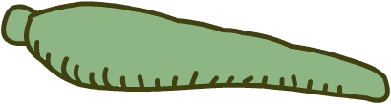 | - predatory or parasitic  - terminal suckers  - hermaphroditic | Phylum Annelida  Class Hirudinea
Gastrotricha  .1-1.5mm |  | - mainly benthic  - head bristles  - eat algae, bacteria, protozoa | Phylum Gastrotricha  Order Chaetonotida
Tardigrades  Little water bears  < 1 mm | 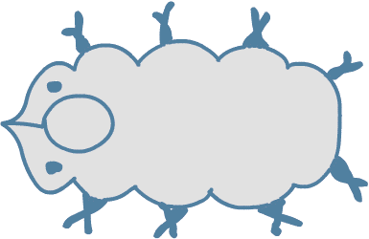 | - head and 4 trunk segments  - 4 pair legs  - eyes  - herbivores | Phylum Tardigrada

Arthropods - segmented, exoskeletons

Name | Picture | Characteristic | Taxonomy
Ostracods  <2mm | 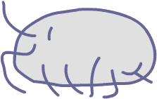 | - bean-like shell  - filter feeders  - bivalve carapace | Class Crustacea  Order Ostracoda  i.e. Cypris sp.
Copepods  .5-3mm | 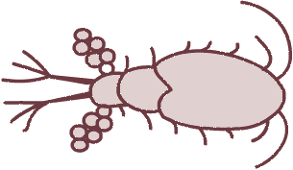 | - long antennae  - tiny eyespot  - holoplankton | Class Crustacea  Order Copepoda
Water fleas  .3-10mm | 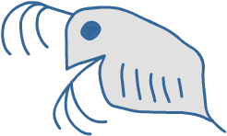 | - antennae  - large compound eye  - holoplankton | Class Crustacea  Order Cladocera  i.e. Daphnia sp
Isopods  5-20mm | 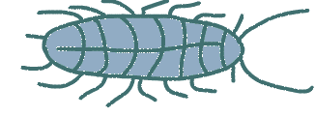 | - flattened  - 7 pairs legs  - scavengers | Class Crustacea  Order Isopoda
Amphipods  5-25mm | 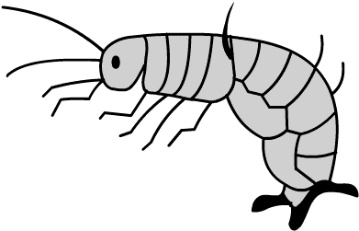 | - curved  - compressed body  - humped back  - scavengers | Class Crustacea  Order Amphipoda
Water mites  .5-5mm | 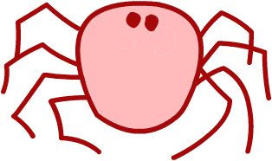 | - 8 legs  - round body  - larvae (parasitic)  - nymph looks like adult | Class Arachnida  Order Acarina
Alderfly nymph  5-25mm | 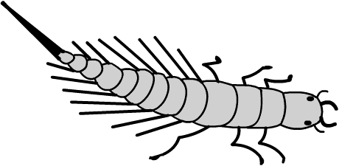 | - one tail  - long filaments along the abdomen  - meroplankton | Class Insecta  Order Megaloptera  Family Sialidae
Caddisfly larva  3-40mm | 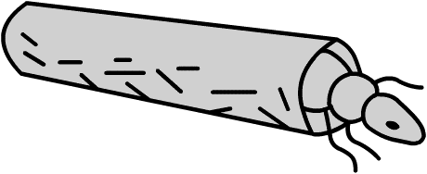 | - cylindrical case for protection  - distinct case but different materials | Class Insecta  Order Trichoptera
Stonefly nymph  <15 mm | 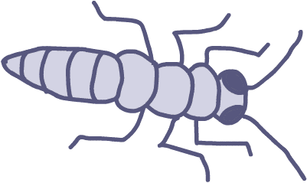 | - two jointed tails (cerci)  - carnivorous  - indicates clean water | Class Insecta  Order Plecoptera
Mayfly nymph  <15mm | 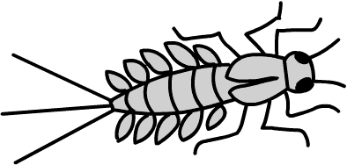 | - three jointed tails0  - leaf-like gills on sides | Class Insecta  Order Ephemeroptera
Damselfly  Nymph  <15mm | 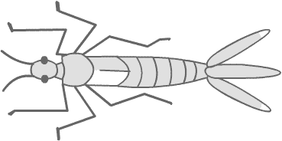 | - three leaf like tail appendages (gills)  - extendable jaws | Class Insecta  Order Odonata  Zygoptera
Dragonfly nymph  <15mm | 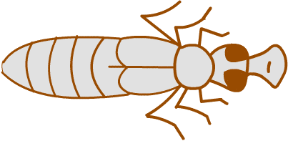 | - robust  - no tail appendages  - extendable jaws | Class Insecta  Order Odonata  Anisoptera
Water boatman nymph.and adult  10-15mm | 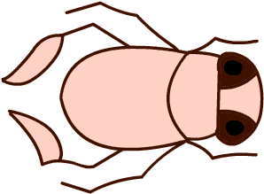 | - no jaws  - tube-like beak  - nymphs don’t have wings | Class Insecta  Order Hemiptera  Family Corixidae
Water beetle  <45mm | 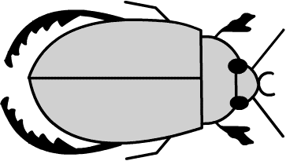adult | - strong jaws  - tough shield  - fierce predator | Class Insecta  Order Coleoptera  Family Elmidae
Water beetle  <45mm | 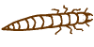nymph | - strong jaws  - long segmented body  - short legs | Class Insecta  Order Coleoptera  Family Elmidae
Mosquito larva  1-20 mm | 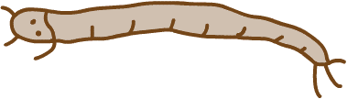 | - long slender body  - moves in undulating s curves | Class Insecta  Order Diptera

Drawings redrawn from http://www.microscopy-uk.org.uk/pond/index.html

