AFRICA WEATHER PATTERNS
Date: __________________
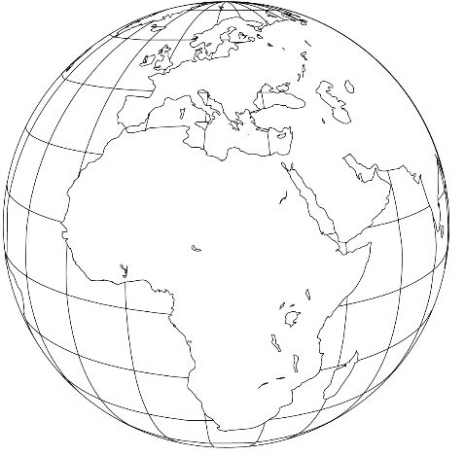
Date: __________________
Date: __________________

