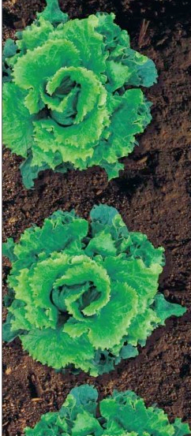
COMPOST PARTY
4th grade is learning about how to compost food waste.

We will be filling the composter during the school day (each class has a separate time).

Day ____________
Time: During class

We need each student to bring in some food waste. Only bring food waste on scheduled day, not before.

Types of food waste we need:
greens: rotten or old lettuce, vegetables (raw or cooked), onion peels or other vegetable parts that were to be thrown away
Fruit: peels or cores (example, banana peels, apple cores). Whole fruit is ok but should be cut into smaller pieces.
Other: egg shells

Do not bring MILK Products (cheese, yogurt, etc)
Do not bring Meat (chicken, fish, beef) (no raw eggs)
Do not bring garden clippings

PLEASE NOTE: Bring the food waste in a zip-lock bag or other sealed container so smell and mess don't get in the classroom.

Questions? contact _________________________________

